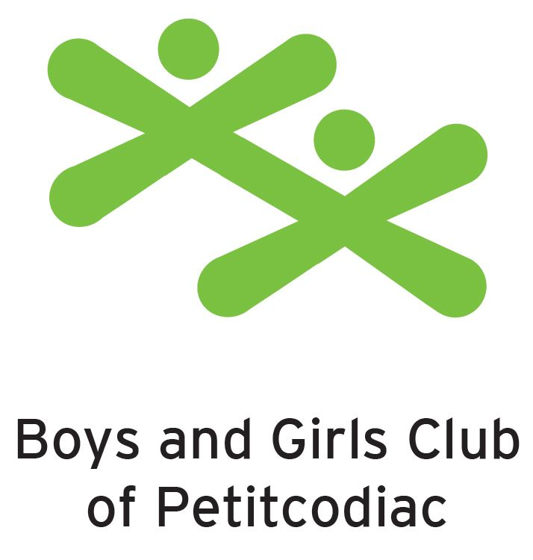
PLANNING FOR OUR NEW NORMAL

OPERATIONAL PLAN
FOR ENSURING EVERYONE’S HEALTH AND SAFETY
IN A COVID-19 ENVIRONMENT

May 13, 2020

Introduction

Because of the COVID-19 pandemic and restrictions necessary to reduce risk, our environments will not appear nor function the same as we left them on March 16 2020. To establish a new normal, additional layer of health and safety measures (physical distancing, screening, handwashing, etc.) are necessary to protect our employees, children and families. And, while it has been well established that physical distancing is the most effective measure for preventing the spread of Covid-19, requiring at least two meters distance between persons, we know this is not feasible in all aspects of caring for young children. As such, this document describes how we will mitigate the risks associated with our work as best we can, and the expectations of all persons entering our centres.

A summary of key strategies to prevent and control COVID-19 spread is provided next, followed by detailed descriptions of the specific steps being taken by Boys and Girls Club of Petitcodiac to protect the health and safety of all patrons and staff.

- Strict exclusion of children or staff who are sick with 2 or more of the following symptoms: fever or signs of fever, new cough or worsening chronic cough, runny nose, headache, sore throat, new onset of fatigue, new onset of muscle pain, diarrhea or loss of taste or smell OR a child displaying purple fingers or toes even as the only symptom. If either of the above criteria is met, those who are sick must stay home, contact 811, and cannot return until fully recovered. If tested, Public Health will inform the individual or parent (when a child is involved) when isolation may be lifted.
- Children or staff who have been identified as having seasonal allergies or who suffer from chronic runny nose/nasal congestion are not required to be excluded.
- Any person arriving from travel outside of New Brunswick must self-isolate for 14 days at home, monitor for symptoms and avoid attending care.
- If a staff or child of the centre tests positive for COVID-19, Public Health will identify who the close contacts are and manage the outbreak with respect to Public Health measures and communication.
- Staff are encouraged to remind children to practice good respiratory etiquette such as covering the mouth and nose with a disposable tissue or the crease of the elbow when coughing or sneezing. Masks are not recommended.
- Staff and children must practice good hand hygiene.
- Increase access to handwashing stations and hand sanitizer.
- Enhance regular environmental cleaning of the facilities including high touch surfaces.
- Items that cannot be easily cleaned must be removed.

- It is recommended that facilities not prepare/provide meals or snacks for children, and that parents provide food for their children.

State of Emergency
A State of Emergency was declared in New Brunswick on March 19, 2020 due to the increased
presence of COVID-19. The following measures are in the order and impact all New Brunswick workplaces:
- Owners and managers of all workplaces, including government, must take every reasonable step to ensure minimal interaction of people within 2 metres of each other, and must comply with all advice to minimize risk issued by the Chief Medical Officer of Health (see “social distancing”).
- Owners and managers of all workplaces, including government, must take every reasonable step required to prevent persons who exhibit symptoms of COVID-19 from entering the workplace, in accordance with advice issued by the Chief Medical Officer of Health or WorkSafeNB (see “active screening”).
- Owners and managers of all workplaces, including government, must also take every reasonable step required to prevent persons from entering workplaces who have travelled outside New Brunswick in the previous 14 days (see “active screening”).
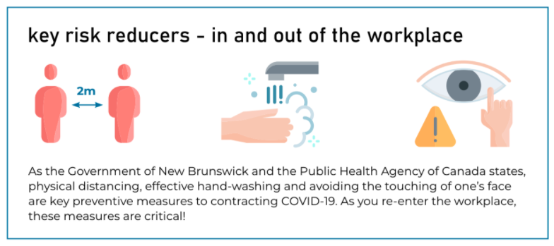
From WorkSafeNB’s Embracing the new Normal

Reducing Risk
Physical distancing is the most effective measure for preventing the spread of Covid-19. Doing so requires at least two meters distance between persons. Unfortunately, this is not something we can achieve, in part or in whole, at all times in our line of work caring and

educating young children. According to WorkSafeNB, this positions our work and environments are higher risk than others. That said, zero risk is not possible in any setting
and is not the goal. We must, however, reduce risk by relying on a combination of controls that improve health and safety.

In the following sections, the controls being implemented at Boys and Girls Club of Petitcodiac are described. Please adhere to signage through centre regarding proper hand hygiene, respiratory hygiene, and physical distancing throughout the facility and outdoor settings.

Physical Distancing
While we cannot ensure physical distancing at all times, staff will do their best to maintain two meter distances from one another and the children, when the situation permits. We will also actively work with the children to keep their distance from one another as well. We recognize this will not always be achievable or feasible.
To permit physical distancing for active screening (described next), two meter increments for persons to wait at each centre will be marked. Our centre will be open for active screening between 7:00 AM and 9:30 AM. If you require screening after 9:30 AM you must contact your centre’s office to arrange screening at 756-2841.
Groupings
Maximum groupings of 15 children (plus staff) and a maximum of two groups per room will facilitate distancing, yet each 15 person group is exempt from the 2-metre physical distancing requirement, per the Office of the Chief Medical Officer of Health New Brunswick. Although exempt, staff will actively encourage children not to touch other children and to practice good personal hygiene. Toddlers and older children will be educated at the beginning of each day on when and how to wash their hands, how to cover their sneezes properly, and the importance of not touching their face or touching others. For each group, the same educator(s) and same group of children will stay together as much as possible and staff to children ratios will be maintained at all times.

In Tiny Tykes we will have the baby room open with 3 children and they will be with one staff. In the 3-year-old classroom there will be a mix of 3- and 4-year old’s, not exceeding 8 children and one staff. The 4-year old’s will be in their classroom with no more than 10 children, 1 staff and 2 ESW’s. In the afterschool program 15 children, 1 staff and an ESW will be in the back room. Another group of 15 children and 1 staff will be in the bowling ally.

In order to accommodate physical distancing requirements, congregating in groups is not permitted. Staff will not be able to congregate for lunch or breaks in common areas to respect physical distancing.

Active Screening
Prior to entering our centres, staff, children, the adult bringing the child into the facility or others deemed essential (e.g. EECD staff) will be actively pre-screened. Entrance and exit doors will be clearly marked with signage on site. This process includes taking body temperature and asking and recording responses to questions provided by the New Brunswick Department of Health.

The main entrance will always be locked. In the morning there will be a staff member at the door to ask the parents the screening questions and to take the children’s temperatures. Parents will line up on the ramp using 2 meter distancing, the ramp will be marked so everyone will know where to stand. The parking stops by the ramp will be closed off with pylons.

Following pre-screening (form attached), those exhibiting symptoms will be advised of the following: contact 811, and the child cannot return until fully recovered. If tested, Public Health will inform the individual or parent (when the child is involved) when isolation may be lifted.
Staff health will be monitored throughout the day by designated individuals, as well, and temperatures taken every five hours. Please note that while strictly enforcing staff health is essential, this could result in child spaces being closed if adequate numbers of staff cannot be maintained. Child-to-staff ratios must always be maintained to ensure child and staff safety.
Movement inside the Centre
Our screening will be available until 9:30 each morning. If you are arriving later then 9:30 you will need to call the office at 756-2841 and arrange a screening.
Please bring only essential items (Early learning Centre: food, including lunch and 2 snacks bedding, extra clothing and a water bottle)(Afterschool: food, including lunch and 2 snacks a set of extra clothes and water bottle) please have it all packed in a bag for easy passing to the screener upon arrival. Children’s bags should be packed for an easy and timely exit.
Also, if possible, please identify one adult for dropping off and picking up children as to limit the number of different people in our centres.
Visitor and Employee Logs
Regular procedure involves staff signing into classrooms in which they are working. At this time, staff will be limiting their movements in the centre and from classroom to classroom.

However, when movement is necessary staff and any other visitors (inspectors, for example) will be required to sign into the space, with the time entered and exited, for contact tracing purposes.

As per the Office of the Chief Medical Officer of New Brunswick, records of household members for each child attending their facility will be updated. A log will be kept for each self-contained group that would include the names of those in the group and date the group was established, in case Public Health asked for it to help with contact tracing, if a COVID-19 case was found in the facility or might have attended a camp.

Hand and respiratory hygiene
Handwashing is one of the best ways to protect yourself and others from getting sick from COVID19 and other germs. Handwashing sinks and hand-sanitizing products are readily available for all patrons. Children must be monitored to ensure they are washing their hands correctly.

As per direction the New Brunswick Department of Health, all persons must wash their hands well and frequently, including in the following scenarios:
- on arrival;
- before and after meals;
- after using the toilet;
- after blowing nose, coughing or sneezing;
- after playing with shared toys;
- after handling animals or their waste;
- when taking medications; and
- after playing outside.

In addition, staff are required to wash their hands:
- before and after handling food;
- after helping a child use the toilet;
- after breaks;
- before and after changing diapers; and
- before and after giving medications
Signage on personal hygiene etiquette such as handwashing; and sneezing and coughing etiquette is posted throughout the facility.
Face Coverings
Face coverings are not being expected of children and staff in early learning and childcare facilities. That said, should children become ill while in our care. Staff have the same expectations and will use it if they become ill.
The following is the direction provided by the Office of the Chief Medical Officer of New Brunswick regarding masks, “Masks are not required for children at Early Learning and Childcare Facilities as these are not settings where people are typically trained on their use, and there is a potential risk of infection with improper mask use. In young children in particular, masks can be irritating and may lead to increased touching of the face and eyes. The only exception is when a child becomes sick at the daycare and a 2-metre distance cannot be maintained from the sick child then the child should wear a non-medical mask, if circumstances allow, until parents come get them.”
For personal protective equipment we will supply community masks for children or staff who may become ill while at the daycare.

Enhanced Sanitation
Routine disease control involves following a cleaning and disinfection schedule to help limit the contamination of the environment. Increasing the frequency of cleaning and disinfecting high-touch surfaces is significant in controlling the spread of viruses, and other microorganisms.

All surfaces, including those general surfaces that are frequently touched, including doorknobs, handrails, light switches, taps and hand sanitizer dispensers will be cleaned at least four times a day by designated persons. These items as well as toys and other hard surfaces in classrooms will be cleaned at least four times daily by educators and again when soiled. Toys that children may put in their mouth will be rinsed with potable water after they have been cleaned and disinfected. Cleaning and disinfection schedules are available by centre.

Out Break Management Plan:
Control measures on suspected cases of COVID-19 include: • If a facility is required to be closed because of an outbreak, Public Health will give the directive to the facility. For large facilities that have multiple licenses e.g. a facility that has various wings with each wing having its own separate licence, the Regional Medical Officer of Health will determine if the entire facility will be required to close during an outbreak. Example Early Learning centre and Afterschool groups.
• If exclusion/isolation is required, we will inform parents/guardians and staff of the situation and of how important this control measure is. Proper exclusion/isolation is one of the most important and effective measures in controlling the spread of disease to others. Parental and staff cooperation is critical. The Boys and Girls Club of Salisbury sick area is the small area that is the entrance to the main offices. Pick-up is to occur within an hour of notification, this is stated in the parent handbook.
• Symptomatic children must be immediately separated from others in a supervised area until they can go home. Where possible, anyone providing care to an ill child should maintain a distance of 2 metres.
• It would be important that the group of combined children/staff the symptomatic child was in, not mix with the rest of the daycare population until the ‘suspect case’ is assessed.
• If a 2-metre distance cannot be maintained from an ill child, if circumstances allow, the child should wear a community mask supplied by the centre.
• Ill staff must immediately isolate from others and wear a community mask until they are able to leave the facility.
• Hygiene and respiratory etiquette must be practiced while the ill child/staff is waiting to be picked up.
• We require temperature checks for staff and children upon arrival and repeat temperature checks at least every five hours thereafter.
• Environmental cleaning and disinfection of the isolation area must be conducted once the ill child/staff has left the facility.
• If an outbreak is confirmed, appropriate notices for parents/guardians at all entrances to the facility to ensure that disease information is available for staff and parents/guardians if needed or requested.

Outdoor Play Areas
Prior to entering the outdoor play area all equipment (swings, glider, monkey bars and plastic climbing structures etc.) will be disinfected by staff members. The children will wash their hands before going outside and staff will ensure children are following good personal hygiene while on the equipment. When the group heads back inside a staff member will disinfect the equipment again and everyone will wash hands once inside the building.
The wooden structures or equipment will not be used at this time due to the inability to disinfect properly.

